**Supplementary File:** Comparison of different models obtained via numerous integration techniques and the validation of the generated models.

Table1: Healthy AM

|  |  |  |  |  |
| --- | --- | --- | --- | --- |
| Integration Method | Number of metabolites | Number of reactions | Number of reactions carrying fluxes | Number of pathways |
| iMAT | 3967 | 4554 | 3990 | 106 |
| E-flux | 5380 | 8073 | 5064 | 132 |
| INIT | 6008 | 8412 | 4552 | 116 |
| mCADRE | 3288 | 3753 | 1191 | 64 |

Table2: M1 phase

|  |  |  |  |  |
| --- | --- | --- | --- | --- |
| Integration Method | Number of metabolites | Number of reactions | Number of reactions carrying fluxes | Number of pathways |
| iMAT | 3244 | 4038 | 3563 | 109 |
| E-flux | 5602 | 8212 | 8204 | 132 |
| INIT | 6124 | 8508 | 4775 | 117 |
| mCADRE | 3287 | 3844 | 1191 | 64 |

Table 3: M2 phase

|  |  |  |  |  |
| --- | --- | --- | --- | --- |
| Integration Method | Number of metabolites | Number of reactions | Number of reactions carrying fluxes | Number of pathways |
| iMAT | 3884 | 4924 | 4742 | 108 |
| E-flux | 5936 | 8483 | 8084 | 132 |
| INIT | 6035 | 8638 | 4926 | 115 |
| mCADRE | 3247 | 3651 | 1038 | 60 |

Figure 1:

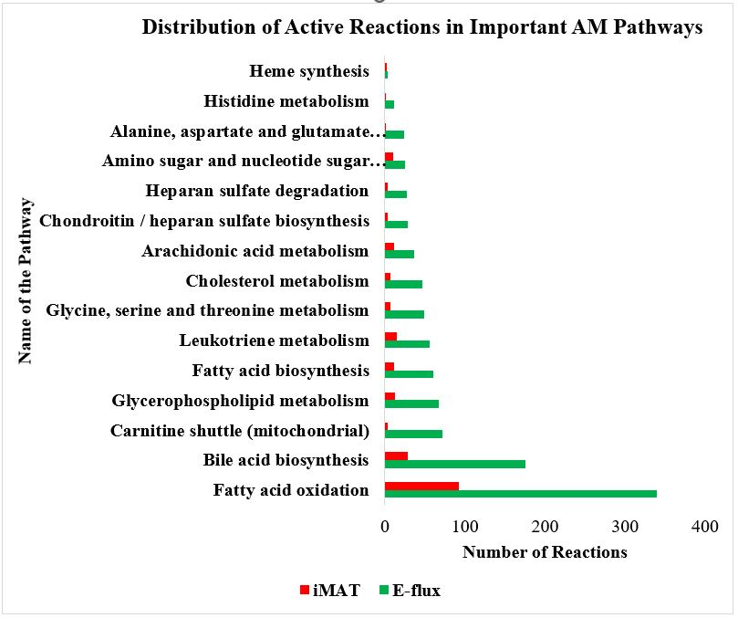

**Table 4:** In the table below, the first column consists of metabolic capabilities of each activated phase as reported in literature. The green arrow refers to the upregulated activity of the pathway and the red arrow shows the inhibition of the pathway.

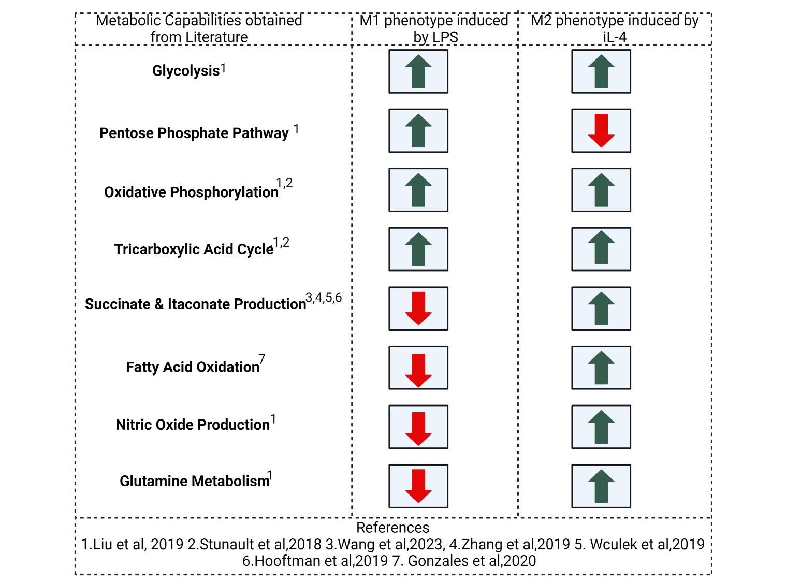

**Table 5:** Biomass Flux comparisons for all state of AM (healthy, M1 and M2 phase)

|  |  |  |
| --- | --- | --- |
| Healthy AM (h-1) | M1 phase (h-1) | M2 phase (h-1) |
| 0.03 | 0.7 | 2.2 |